Exploring the Interplay: Social Trends and Sociology in Interior Design

Interior design isn't just about aesthetics; it's a reflection of societal values, cultural norms, and individual preferences. At its core, interior design is an interdisciplinary field that draws inspiration from various sources, including art, architecture, psychology, and sociology. In this article, we delve into the intricate relationship between social trends and sociology in interior design, exploring how societal changes shape design choices and vice versa.

## Understanding Sociology in Interior Design

Sociology looks at the behaviour, beliefs, and structures of societies. In Interior Design, sociology examines how people interact with their environments, how spaces influence behaviour, and how cultural values are expressed in design decisions. Designers will take into account sociological factors, such as cultural diversity, social relationships, and lifestyle preferences. All of this is particularly relevant when creating spaces in response to clients’ needs and requirements.



Fig 1. Canva (n.d.), An Interior Designer at his Desk

## Impact of Social Trends on Interior Design

A trend is a general direction, in which something is developing towards, or becoming more popular. Generally speaking, social trends will play a significant role in shaping interior design preferences. As society evolves, so too do design trends. These will often reflect changes in lifestyle, technology, and culture which will subsequently alter the choice in material finishes, colour schemes etc. For example, the rise of remote work has led to an increased demand for home offices and multifunctional spaces that cater to both work and leisure activities. The pandemic of 2020 has also created a shift centering on the user with focus towards wellbeing, and people seeking healthier lifestyles. Similarly, growing environmental awareness has sparked a trend towards sustainable and eco-friendly design solutions.

## 

## Cultural Influences

# Interior design is enriched by cultural diversity, with each culture bringing its unique aesthetic traditions and design principles. Understanding sociological elements helps designers navigate cultural variations, and create spaces that respect and celebrate diversity. Whether it's integrating traditional elements into contemporary design, or adapting spatial layouts to accommodate cultural practices, sociology provides valuable perspectives for creating culturally inclusive environments.

Fig 2. Canva (n.d.), Interior Design of a Room in Japan based on Wabi Sabi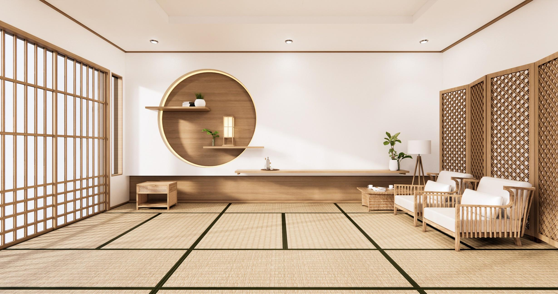

## Social Class and Design

In order to decide on final material finishes and processes, discussing the client’s budget for a project is an imperative part of the design process, regardless of any taboo attached to the conversation. Social class refers to the hierarchical divisions within society, based on factors such as financial wealth, income, education, and occupation. These elements influence individuals' socioeconomic status and access to resources. Social class influences not only the affordability of design choices, but also aesthetic preferences and lifestyle aspirations. High- income households may gravitate towards luxurious materials, custom furnishings, and spacious layouts, while budget-conscious consumers may prioritise functionality and affordability.

Understanding the socioeconomic context allows designers to tailor their solutions to meet the needs and aspirations of diverse clientele.

## 

## 

## 

Fig 3. Canva (n.d.), Moroccan Riad

## Psychological Impact of Design

Sociology intersects with psychology in understanding how design influences human behaviour and emotions. Factors such as colour, lighting, and spatial arrangement can impact mood, productivity, and social interaction. For instance, research suggests that warm colours promote sociability and relaxation, while cool colours evoke calmness and concentration. By applying socio psychological principles, designers can create environments that foster well-being and enhance quality of life.

## Designing for Social Interaction

Interior spaces serve as platforms for social interaction, shaping interpersonal dynamics and community engagement. From residential living rooms to commercial spaces, sociological insights inform design decisions aimed at promoting socialisation and connectivity. Open floor plans, communal seating arrangements, and interactive elements encourage collaboration and engagement, creating an enriched sense of belonging and a shared experience.



Fig 4. Image generated using AI platform (2024), Social Interaction

The relationship between social trends and sociology in interior design is dynamic and multifaceted. By integrating sociological perspectives into their practice, designers can create spaces that not only reflect contemporary trends, but also resonate with the values and aspirations of society. From cultural inclusivity to psychological well-being, sociology enriches interior design by providing a deeper understanding of human behaviour, societal dynamics, and the evolving needs of communities. As design continues to evolve, the interplay between social trends and sociology will remain a cornerstone of innovative and impactful design solutions.